**Study guide 506 Research Exam 2025**

**Lecture: Research Questions:**

1. **HHS (Human Health Services) definition of research (lec1- slide 12)**
   1. Research is defined in the Privacy Rule as, “**a systematic investigation**, including research development, testing, and evaluation, designed **to develop or contribute to generalizable knowledge**.”
   2. Reproducibility, Defensibility
2. **Examples of data that are not human subjects**  (lec1 – slide19)
   1. If the information (data) or biospecimens to be used are not identifiable in any way and there is no way to link the information back to the subjects from whom it was collected, the research study does not meet the definition of human subjects research and does not require IRB review and approval.
3. **Quality improvement and Health Services Research (HSR)** **(lec1 – slide 17)**
   1. HSR
      1. A human subject is "a living individual about whom an investigator (whether professional or student) conducting research:
      2. Obtains information or biospecimens through intervention or interaction with the individual, and uses, studies, or analyzes the information or biospecimens; or
      3. Obtains, uses, studies, analyzes, or *generates identifiable private information or identifiable biospecimens*."
   2. QI
      1. Is not research
         1. Similarities to HSR
            1. Both involve a systematic investigation that is carefully designed to achieve reliable and valid results
            2. Both involve analysis of data
            3. Both may involve the implementation of a new intervention
            4. Both may result in a presentation or publication
         2. Differences to HSR
            1. QI project are often flexible and incremental in design, employing strategies such as plan – do- study- act cycle.
            2. QI interventions often have been proven to be successful elsewhere and are widely accepted in the professional/discipline
            3. Informed consent is NOT required for quality improvement projects since they pose only minimal risk. Because quality improvement is an integral aspect of normal health care operations, consent to be included in QI projects is part of the patient’s consent to receive treatment
4. **The 11 steps to the research lifecycle (lec1 –slide 34)**
   1. Observe, Search, and Discover
   2. Develop Questions/ Hypothesis
   3. Design Study
   4. Acquire Materials
   5. Collect Data
   6. Store Data
   7. Analyze Data
   8. Interpret Findings
   9. Write Report
   10. Publish and Share
   11. Replicate
5. **3 observational levels (lec12 – slide 37)**
   1. Basic (T0)🡪 translation (T1-T2)🡪 Applied (T3-T4)
      1. T0 – Basic Scientific Discovery
      2. T1 – Translation to Humans
      3. T2 – Translation to Patients
      4. T3 – Translation to Practices
      5. T4 – Translation to Population
6. **FDA phases of drug development (Phases I to IV)  (lec1 slide 42)**
   1. Phase I – is it safe?
   2. Phase 2 - Does the treatment work?
   3. Phase 3 – Is the treatment better?
   4. Phase 4 – What else do we need to know?
7. **What a research umbrella is (lec1 slide 53)**
   1. Area🡪Topic🡪 Question
      1. Research Area – Large
      2. Research Topic – Medium
      3. Research Question – Small  
         *focused drive research design to produce feasible measureable and repeatable studies

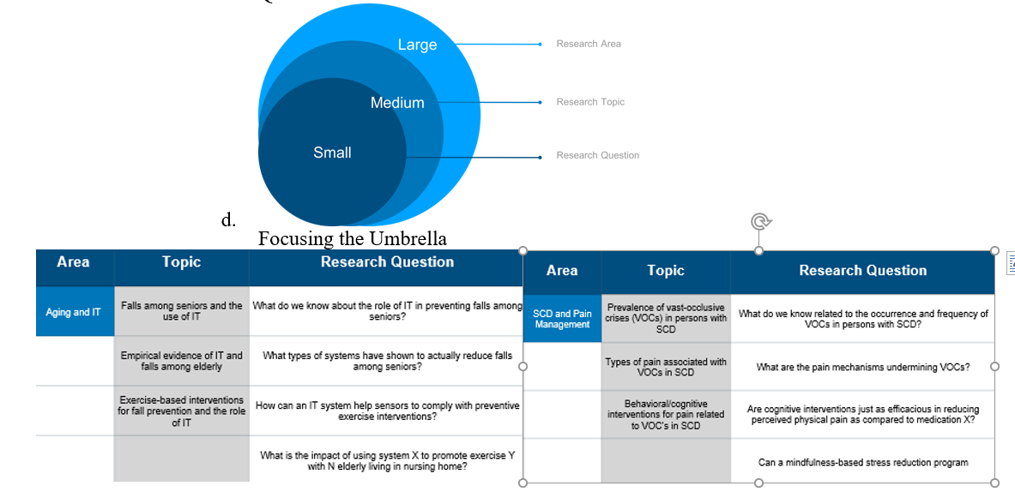

1. **Which federal agencies provide research topics/areas of interest to healthcare researchers (lec1 slide57)**
   1. CDC
   2. HealthyPeople
   3. NIH, CDC, FDA, PCORI, AHRQ
2. **FINER criteria  (lec1 slide 64)**
   1. Feasible
      1. adequate subjects
      2. adequate technical expertise
      3. affordable in time and money
      4. manageable scope
   2. Interesting
      1. Getting the answer intrigues, investigator, peers, and community (ie: HealthyPeople initiative)
   3. Novel
      1. Confirms
      2. Refutes or extends previous findings
   4. Ethical
      1. Amenable to study that institutional review board would approve
   5. Relevant
      1. To scientific knowledge
      2. To clinical and health policy
      3. To future research
3. **PICOT format (lec1 Slide 65)**
   1. Population/Problem
   2. Intervention/Exposure
   3. Comparison
   4. Outcome
   5. Time

**Lecture: Ethics**

1. **What the Belmont Report and Common rule are (lec 2 – slide 10)**
   1. Bioethics
      1. Respect for Persons (autonomy)
         1. Treat individuals as autonomous agents
         2. Persons with diminished autonomy are entitled to protection
      2. Nonmaleficence
         1. Minimize harm
      3. Beneficence
         1. Maximize benefits and minimize harms
      4. Justice/Equity
         1. Fair, equitable treatment for all, equal access to participation regardless of socioeconomic, race, differences
         2. Who ought to receive the benefits of research and bear its burdens?
   2. Common Rule
      1. Describes the types of research subject to regulation
      2. Defines key terms such as research, human subject and minimal risk
      3. Requires a written assurance of compliance with the common rule
      4. Set forth requirements for an Institutional Review Board’s (IRB) membership, authority, review procedures, records and criteria for approval
      5. Lists the general requirements for informed consent
   3. Other Ethical Concepts
      1. Transparency
      2. Responsibility
      3. Autonomy
      4. Trust
      5. Dignity
      6. Fairness
2. **History of hospital ethic committees (lec2 slide 20)**

HEC – to deal with Ethical issues in healthcare.

Started in 1960 limited dialysis machines

Today – lung and liver transplants, EOL, unconscious patients, homeless, no families

Interdisciplinary team (nurses, chaplains, physicians, social workers, lawyers, etc)

* 1. Nazi Germany – Human Experimentation
  2. United States – Tuskegee Study (1932-1972)
  3. San Quetntine – hormone research (1920-1950)
  4. Atomic Energy Commission radiation testing (1960)
  5. Sloan Kettering injected live cancer cells into prisoners (1950-1960)
  6. CRISPR babies (2018 -2019)
     1. D. Jiankui announced he had edited the genes of two twins in utero without following basic safety protocols
  7. 2018 Monkey cloning
     1. “Technically speaking on can clone humans”
  8. (2015-2019)
     1. Dr Segio Canavero
        1. 1908 head added to dogs
        2. 1950 more two-headed dogs
        3. 1965 dog brain transplant
        4. 1970 first head transplant in a monkey
        5. 2002 head transplant in rate
        6. 2015 GEMINI
     2. Developing relevant interventions to protect patient rights
     3. Proposing solutions to real or imagined conflicts
     4. Modifying patient care protocols to improve quality
     5. Enhancing patient/family satisfaction
     6. Providing the staff with ethical education
     7. Developing strategies to prevent future ethical issues
     8. Satisfying the perceived needs of the staff
     9. Providing the staff with moral support
     10. Discontinuing undesirable or ineffective treatments
     11. Minimizing the risk of legal liability

1. **DSM(P) - DSMBs - what they are and when they are used (lec2 slide 23)**
   1. Data Safety Monitoring (plan)/ Data Safety Monitoring Board
   2. Some studies may require additional levels of data and safety oversight and monitoring
   3. Clinical trials require additional monitoring by a committee
   4. Data and Safety Monitoring Board (DSMB), or single or dual Safety Officers (s)(SOs)
   5. Large observational studies may require additional oversight by an Observational Study Monitoring Board (OSMB)
2. **Data ownership trends of healthcare data in the US (lec2 slide 27)**
   1. Who owns your Health data? Hospital, Physician, or Patient
   2. Hospital and/or physician own medical record
   3. Patient owns information in medical record
   4. No law identified conferring specific ownership or property right to medical record

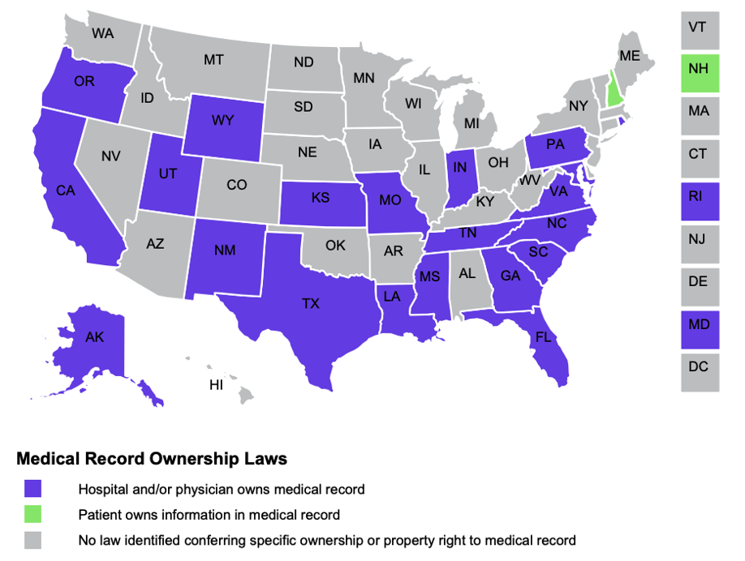

1. **‘Derivative work’ and its implications for Ai in human research and industry (lec 2 slide 30)**

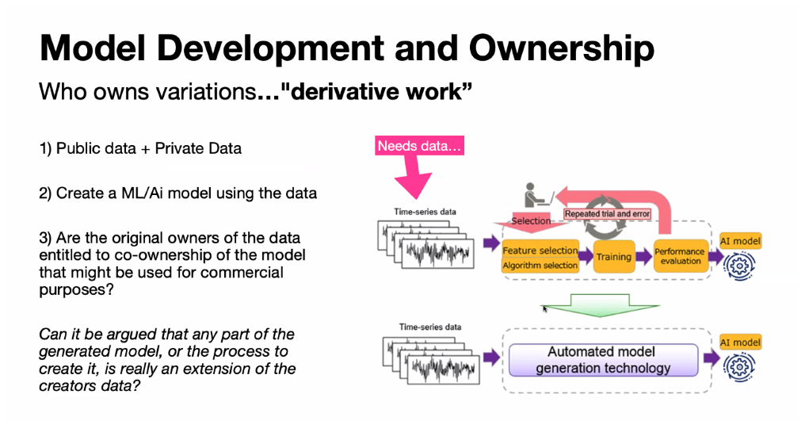

* 1. Who owns variations “derivative work”
     1. Public data + private data
     2. Create a ML/Ai model using the data
     3. Are the original owners of the data entitled to co-ownership of the model that might be used for commercial purposes?
     4. Can it be argued that any part of the generated model, or the process to create it, is really an extension of the creators data?
        1. Potential influencing factors (ie: 23 and me)
           1. Is there a copyright
           2. Are there terms of services/use (ToS)
           3. Is there a license agreement

1. **The story of henrietta lacks (lec 2 slide 33)**
   1. Should you ‘co-own’ or have rights to the derivate of a drug that was developed using your DNA by Pfizer?
   2. African-American woman whose cervical cancer cell are the source of the HeLa cell line (at John Hopkins)
   3. First immortalized human cell line and one of the most important cell lines in medical research.
   4. Over 120,000 studies have been written citing the use of these cells
   5. No money to her or her family
2. **Examples of non-traditional PII/PHI sources (lec2 slide 41)**
   1. HIPPA protected
      1. PHI (Protect Health Information) (lab, payer, prescriptions, public health, person/patient, amb center, hospital MRN)
         1. Individually identifiable health information that is transmitted or maintained by covered entity
      2. PII (Personally Identifiable Information) (ie: SSN, NPI, IP, MAC)
         1. Created or received by a covered entity
         2. Relates to health of an individual
            1. Identifies the individual
            2. Reasonable to believe information can be used to identify the individual
   2. **NON-traditional data sources of PII/PHI (lec2 slide 44)**

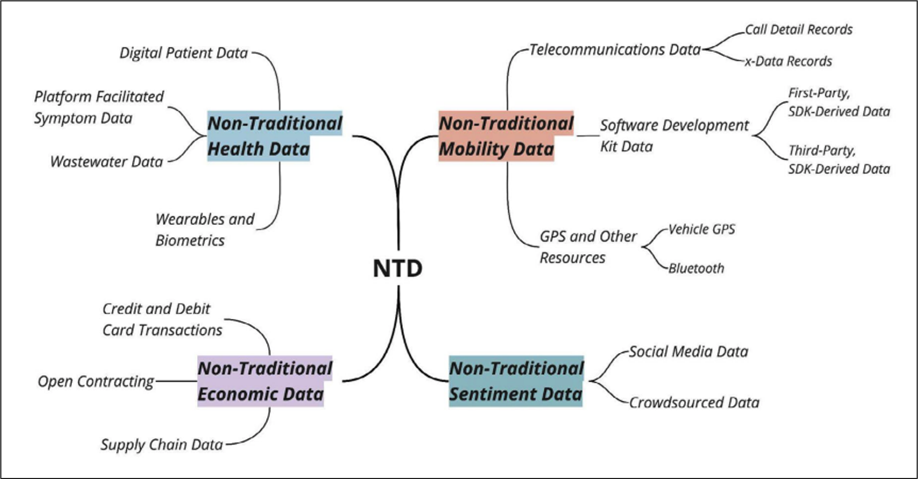

* + 1. **Health**
       1. Digital Patient data
       2. Platform Facilitated Symptom data
       3. Wastewater data
       4. Wearables and Biometrics
    2. **Economic**
       1. Credit and Debit Card Transcations
       2. Open Contracting
       3. Supply Chain Data
    3. **Mobility data**
       1. Telecommunications data
          1. Call detail records
          2. X data records
       2. Software Development kit data
          1. First-party SDK derived data
          2. Third-party SDK derived data
       3. GPS and other resources
          1. Vehicle GPS
          2. Bluetooth
    4. **Sentiment Data**
       1. Social Media Data
       2. Crowdsourced Data
       3. Blogs

1. **Covered entity versus Business Associate (BA) (lec 2 slide 45)**
   1. Covered Entities
      1. Healthcare provider “who transmit any health information in electronic form in connection with a transaction
      2. Health plans
      3. Healthcare clearinghouses
   2. Business Associates
      1. Provide services on behalf of covered entities requiring the disclosure of protected health information
   3. Hybrid Entities
      1. Activities include “covered” and “non-covered” functions
2. Safe Harbor versus Expert Determination for de-identification
   1. Expert determination
      1. Apply statistical or scientific principles
      2. Very small risk that recipient can ID individual
   2. Safe harbor
      1. Removal of 18 types of identifiers
      2. No actual knowledge of residual information can identify individual

* 1. De-identification
     1. HIPAA requires that medical data remains anonymous, but does not consider raw senor data (such as skin temperature and accelerometer (ACC) data) as being privacy-sensitive, and therefore does not require that publicly-shared data of this type be encrypted or subject to the same general protections it affords to traditional forms of patient data, such as health records.

1. **Difference between a rule-based versus non-knowledge based CDSS - Clinical Decision Support**
   1. CDSS that are non-knowledge based still require a data source, but the decision leverages artificial intelligence (AI), machine learning (ML), or statistical pattern recognition, rather than being programmed to follow expert medical knowledge
   2. 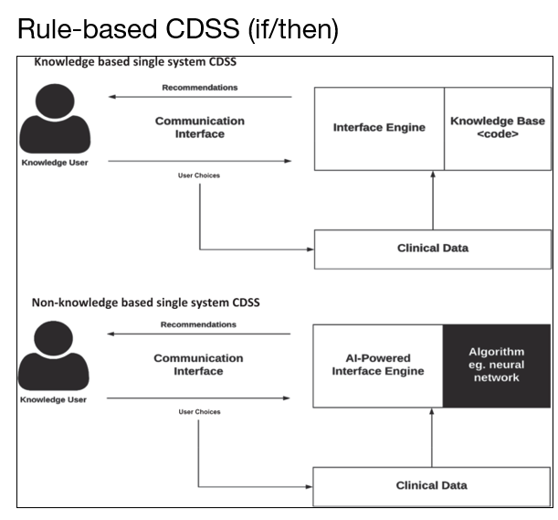
   3. 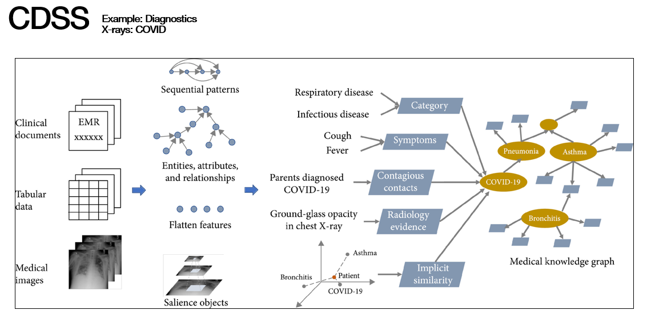

**Lecture: Lit Reviews (lec 3 slide 6)**

1. Levels of evidence (what is at the top versus bottom)
   1. Level 1 – Meta-analysis of Homogenous RCTs (Randomized Control Trial)
   2. Level 2 - Meta-analysis of Level2 or Heterogeneous Level1 Evidence Prospective Comparative Study
   3. Level3 – Review of Level3 Evidence Case-control Study Retrospective Cohort Study
   4. Level4 – Uncontrolled Cohort Studies – case series
   5. Level5 – Expert Opinion, Case Report, Personal Observation
   6. Foundational Evidence – Animal Research, In Vitro Research, Ideas, Speculation

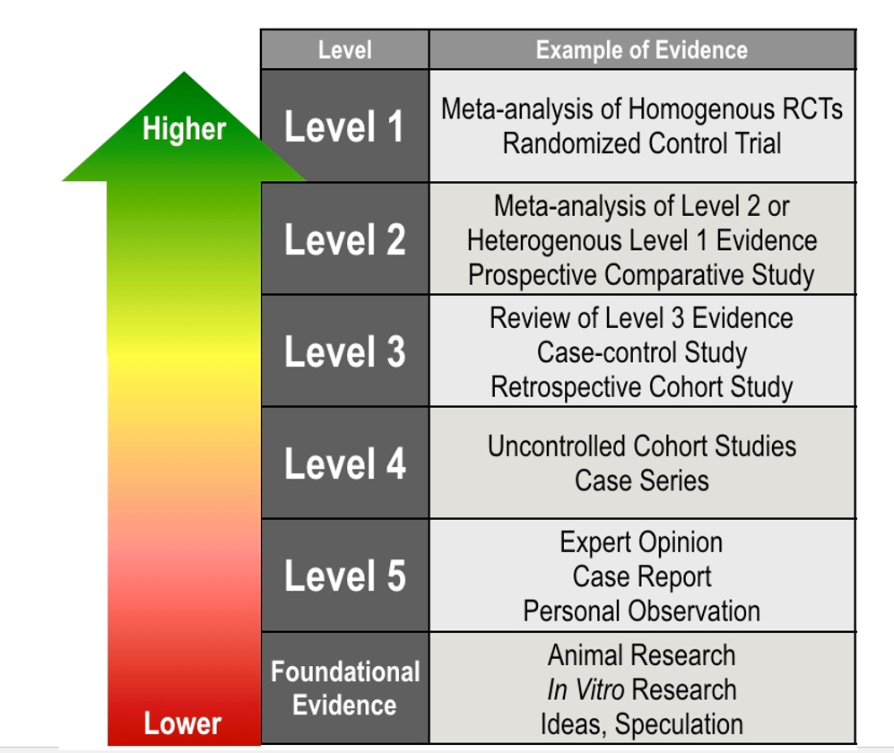

1. Systematic versus Literature Review
   1. Systematic Review
      1. High-level overview of primary research on a focused question that identifies, selects, synthesizes, and appraises all high quality research evidence relevant to that question.
   2. Literature Review
      1. Qualitatively summarizes evidence on a topic using informal or subjective methods to collect and interpret studies
      2. Qualitative assessments of the literature and data sources pertaining to clinical topics, emphasizing factors such as cause, diagnosis, prognosis, therapy, or prevention.
      3. Address specific question or issue that is relevant for clinical practice and provide evidence-based, balanced, patient-oriented review on a focused topic.
      4. Image
2. Meta versus non-meta analysis for systematic reviews
   1. Meta-analysis is a statistical technique for combining the results of independent, but similar, studies to obtain an overall estimate of treatment effect
      1. Common questions addressed in meta-analysis are whether one treatment is more effective than another or if exposure to a certain agent will result in disease
   2. Systematic review - WITH meta-analysis
      1. These manuscripts are systematic, critical assessments of literature and data sources pertaining to clinical topics, emphasizing factors such as cause, diagnosis, prognosis, therapy, or prevention, and that includes a statistical technique for quantitatively combining the results of multiple studies that measure the same outcome into a single pooled or summary estimate.
      2. Best practice is to utilize a PRISMA flow diagram and checklist.
      3. Authors of meta-analyses of observational studies should use the MOOSE checklist.
   3. Systematic review - W/O meta-analysis
      1. Systematic Reviews are critical assessments of the literature and data sources pertaining to clinical topics, emphasizing factors such as cause, diagnosis, prognosis, therapy, or prevention.
      2. Systematic Reviews should address a specific question or issue that is relevant for clinical practice and provide an evidence-based, balanced, patient-oriented review on a focused topic.
   4. Meta-analysis is a statistical technique for **combining the results of independent, but similar, studies** to obtain an overall estimate of treatment effect
   5. Common questions addressed in meta-analysis are whether **one treatment is more effective than another** or if **exposure to a certain agent will result in disease**
   6. **Standard Mean Difference (SMD)**
      1. Standardize Mean Difference (SMD): The SMD is a metric used to measure the magnitude of the effect size in studies that report outcomes using different scales or measurement units.
      2. When outcome measures across studies are not directly comparable, such as when different studies use different measurement scales or instruments, the SMD is commonly used to express the effect size consistently.
      3. It standardizes the mean difference between groups by dividing by the pooled standard deviation.
         1. One study measures the effectiveness of a treatment using a pain scale from 0 to 10, it has experimental and control group
         2. While another study uses a quality-of-life questionnaire with a different range (0-100), it has experimental and control group

Confidence Intervals (CI)

1. Confidence intervals provide a range of values within which the true effect size is likely to fall.
2. They quantify the uncertainty associated with the estimated effect size.
3. Cis are typically reported alongside the point estimate (e.g., SMD) to indicate the precision of the estimate.
4. Limitations of a literature review
   1. **They encounter the same pitfalls as primary research include but not limited to:**
   2. Repeatability
   3. Bias (publication, etc.)
   4. Appropriate uses of methodology and statistics
   5. Small effects of interventions may be magnified.
   6. Considered as being a wasteful use of time and resources if poorly done.
5. PRISMA: what is it and why was it developed
   1. Preferred Reporting Items for Systematic Reviews and Meta-Analyses
   2. **PRISMA Response** 
      1. An international, collaborative effort to address subpar reporting of review reports.
      2. 1996: QUORUM (Quality of Reporting Meta-analyses of RCTs)
      3. 2009: PRISMA (Preferred Reporting Items for Systematic Reviews and Meta-analyses) is a result of QUORUM revisions and additions.
      4. Intended to be a living document.
   3. **PRISMA Aims** 
      1. Improved reporting of SRs and meta-analyses
      2. Can be used for SRs that utilize other types of research
      3. Useful for critically appraising other SRs (but is not to be used as a quality assessment instrument).
   4. **27-item checklist**
   5. **3-phase flow diagram** 
      1. **PRISMA extensions**
         1. **Abstracts**
         2. **Equity**
         3. **Harms**
         4. **Individual Patient data**
         5. **Network Meta-Analyses**
         6. **Protocols**
         7. **Diagnostic Test Accuracy**
         8. **Scoping Review**
         9. **Extensions in Development (protocols for children)**
   6. Table 1. Checklist of items to include when reporting a systematic review or meta-analysis.
6. Mesh terms: what are they, how are they used, what purpose do they serve
   1. MeSH stands for **Medical Subject Headings**.
   2. It is a controlled vocabulary used by PubMed to **standardize and provide hierarchical terms** that represent specific concepts or topics in the field of medicine and healthcare
   3. MeSH terms follow a **tree-like structure**, with broader terms at the top and narrower, more specific terms branching out.
   4. You can use MeSH terms to construct **focused queries**, combining different terms using Boolean operators (AND, OR) to refine your search results and find articles that closely match your research interests.
   5. Main Headings: preferred terms, MeSH headings, or descriptors
   6. Subheadings: qualifiers
   7. MESH TOOLS
      1. Mesh on demand - <https://meshb-prev.nlm.nih.gov/MeSHonDemand>
      2. You insert your text, get back potential concepts

**Lecture: Qualitative Methods**

1. What is visual ethnography
   1. Visual representation of data sets -- Seeing the image helps give more information - check Gapminder dollarsheet
2. The opinion put forth by Forsythe and Buchanan in 1992 about research of computer systems
   1. Researchers in several disciplines have suggested that the dominance of **quantitative methods have *neglected social and cultural processes surrounding*** the development and implementation of computer systems [Forsythe and Buchanan, 1992; Jirotoka and Goguen, 1994]
   2. For the evaluation of **non-technical aspects of system functionality and acceptability, the methods of qualitative social science are more suitable** (than quantitative and experimental approaches
   3. Methods like participant observation and interviewing **can provide systematic data on patterns of thought and behavior in natural workplace settings**.
3. Difference between inductive versus deductive research strategies
   1. QUAL is mostly characterized as adopting an **inductive** research strategy as compared to quantitative research which is mostly characterized as **deductive**
   2. Research that is purely ***inductive:*** starts with the collection of data and moves from there to a general conclusion. *It involves the derivation of a general principle from a set of specific observations*
   3. Research that is purely ***deductive:*** begins with a theoretical system, operationalize the concepts of that system and then *sets out to gather empirical data to test that system*
   4. QUAL methods are particularly suited to answering:

‘**How does** this come to happen?’

*VS the QUANT questions of ‘How many?’, ‘How much?’ or ‘How often?’*

* 1. Some qualitative researchers ***see describing rather than explaining*** *the phenomena* as the central goal of qualitative research

1. The 5 core qualities of qualitative methodology (perspective, environment, context, process, flexibility)
   1. **Adopting perspective**
      1. Provides the opportunity to get close to those being studied, so as to appreciate their **perspectives** and the meanings which inform their behaviors [**emic/etic**]
   2. **Description of Setting (environment)**
      1. by focusing upon the **mundane detail** of what is going on in a setting, qualitative researchers are in a position to challenge routine, but unexamined, assumptions about familiar social settings.
      2. Environment
         1. EX1: Physical Layout: Describe the layout of the healthcare facility, such as the arrangement of patient rooms, waiting areas, and treatment areas. Note the size, flow, and organization of the physical space and how it contributes to the overall healthcare environment.
            1. Example: The hospital consists of multiple wings, with a centralized nursing station and corridors leading to different departments. Patient rooms are arranged in a circular layout around a central nurses' station to ensure easy access and visibility.
         2. EX2: Architecture and Design: Examine the architectural features and design elements of the healthcare facility. Describe the style of the building, the materials used, or any specific design elements that contribute to the ambiance or functionality of the space.
            1. Example: The outpatient clinic features large windows, allowing ample natural light to enter and create a welcoming and calming environment. The design incorporates warm colors and natural textures to promote a healing atmosphere.
         3. EX3: Furniture and Equipment: Identify and describe the furniture, medical equipment, and tools present in the healthcare setting. Note their placement, functionality, and how they support patient care and interactions within the environment.
            1. Example: The emergency department is equipped with examination tables, medical carts, and specialized monitoring equipment. Patient beds are adjustable to accommodate various medical procedures, and comfortable seating is available for family members in the waiting area.
         4. EX4: Decor and Aesthetics: Consider the aesthetic aspects of the healthcare setting, including colors, artwork, or signage. Describe how these elements contribute to the overall ambiance or create a soothing and reassuring atmosphere for patients and their families.
            1. Example: The pediatric wing features colorful murals, playful artwork, and interactive displays to create a child-friendly environment. Signage with cheerful graphics and clear directions help patients navigate the facility with ease
         5. EX5: Natural (surrounding) Environment: Discuss the natural environment surrounding the healthcare facility, if applicable. Describe the views, landscaping, or access to outdoor areas that contribute to the healing environment or provide moments of respite for patients.
            1. Example: The rehabilitation center is surrounded by gardens, providing patients with a serene outdoor space for therapeutic activities and relaxation. The views of the nearby park contribute to a sense of tranquility and connection to nature.
         6. EX6: Accessibility and Safety: Evaluate the accessibility and safety features of the healthcare setting. Describe aspects such as wheelchair ramps, handrails, clearly marked exits, adequate lighting, and other measures in place to ensure patient and staff safety.
            1. Example: The hospital has designated accessible entrances with automatic doors and spacious hallways to accommodate patients with mobility challenges. Clearly marked emergency exits and strategically placed hand sanitizer stations enhance safety protocols.
   3. **Context and Holism**
      1. whereas many quantitative researchers aim to isolate causal relationships from the context in which they occur, **qualitative researchers eschew such context-stripping** and **place complexity at the centre of their research**…understanding the phenomenon of interest holistically
         1. Ex1: Healthcare Intervention Adaption
            1. Research can investigate how healthcare interventions are adapted or modified to fit within specific contexts.
            2. This may involve examining the cultural, organizational, or structural factors that influence the implementation and effectiveness of interventions, such as mental health programs or community health initiatives
         2. Ex2 healthcare disparities
            1. Researchers can explore social determinants of health, structural barriers, and cultural biases that influence access to healthcare, healthcare utilization patterns, and health outcomes among different populations
   4. **Emphasis on Process**
      1. Qualitative researchers emphasize the **processual** and dynamic nature of social life. This is associated with a preference for *longitudinal* designs and for prolonged engagement in the setting under study
         1. Ex1: chronic disease
            1. Longitudinal Exploration of Chronic Illness: Qualitative research can adopt a longitudinal design to understand the evolving experiences and management strategies of individuals living with chronic illnesses over time.
            2. Researchers can engage with participants repeatedly, capturing changes in symptoms, treatment adherence, coping mechanisms, and the impact of the illness on their daily lives.
         2. Ex: Temporal Care dynamics - small PCP and healthcare practices
            1. Qualitative research can explore the temporal aspects of healthcare practices, such as understanding how routines, schedules, and timing impact healthcare delivery.
            2. Researchers can investigate the influence of temporal factors on patient experiences, healthcare workflows, and coordination of care
   5. **Design Flexibility**
      1. Unlike most quantitative research, qualitative researchers are often reluctant to foreclose on the design of their study in advance of the data collection
      2. They sometimes describe their design as **emergent** during the course of the study
      3. Commitment to flexibility in research design is associated with a reluctance to impose prior assumptions on the people or settings being studied, with the attendant risks of **distortion** and **ethnocentrism**
2. Emic versus Etic
   1. Emic and etic perspectives are complementary and can be used in combination to gain a more comprehensive understanding of a cultural phenomenon.
   2. **Emic (INSIDER) Perspective:**
      1. Focuses on the insider's or *participant's point of view* and subjective understanding of a culture or phenomenon.
      2. Emphasizes the unique meanings, values, and experiences attributed by the members of a specific cultural group.
      3. Aims to capture the *cultural nuances, context-specific behaviors, and local interpretations*.
      4. Involves immersing oneself in the culture or community being studied to gain an in-depth understanding from an insider's perspective.
      5. Often *uses qualitative methods such as interviews, participant observation, and ethnographic research*.
   3. **Etic (OUTSIDER) Perspective:**
      1. Focuses on an *outsider's or observer's* perspective of a culture or phenomenon.
      2. Emphasizes *objective, universal, and comparative aspects across cultures or phenomena*.
      3. Seeks to identify commonalities, patterns, and general principles that can be applied across different cultural groups.
      4. Uses a more detached and analytical approach to study cultural phenomena.
3. Difference between 4 sample techniques for qual (purpose, convenience, quota, snowball)
   1. Purpose
      1. Purposeful sampling is a non-random sampling technique commonly used in qualitative research.
      2. It involves intentionally selecting participants based on *specific criteria or characteristics that align with the research objectives*, allowing researchers to gain in-depth insights from individuals who possess relevant knowledge, experiences, or perspectives related to the research topic.
      3. Maximum Variation
         1. Maximum Variation (Heterogenous): Selecting participants who represent a wide range of characteristics or experiences to capture diverse perspectives within the research topic.
            1. EXAMPLE: a study on patient experiences with a specific healthcare intervention, purposefully sampling individuals with the best and worst experiences to understand the full spectrum of perspectives
      4. Homogenous
         1. Homogenous : Selecting participants who share specific characteristics or belong to a particular subgroup relevant to the research focus.
            1. EXAMPLE: a study on the experiences of healthcare providers implementing a new protocol, purposefully sampling participants from a specific department or with a particular level of expertise.
      5. Deviant
         1. Deviant: Selecting participants with unusual or special circumstances that deviate from the norm.
            1. EXAMPLE: a study evaluating the implementation of healthcare practices during the COVID-19 pandemic, purposefully sampling participants who successfully implemented protocols under challenging circumstances
   2. Convenience
      1. Convenience sampling involves selecting participants based on their easy accessibility or availability.
      2. Researchers gather data from cases that are readily accessible or convenient. While it may lack representativeness, convenience sampling can provide quick and practical insights.
      3. An example in healthcare could be gathering **data from patients in a waiting room of a clinic or hospital.**
   3. Quota
      1. Quota sampling involves selecting a predetermined number of participants from different subgroups based on specific characteristics.
      2. The goal is to ensure adequate representation of each subgroup.
      3. For instance, in a study examining healthcare communication, the researcher **may set quotas for the number of doctors and nurses to ensure balanced representation.**
   4. Snowball
      1. Snowball sampling relies on participant referrals to recruit new participants. Initially, the researcher identifies and interviews a few key participants who then suggest other potential participants who may have relevant experiences or knowledge.
      2. This method is particularly useful when studying populations that are difficult to reach. In healthcare research, snowball sampling could be employed to identify patients with rare conditions or individuals involved in specific healthcare movements.
4. Definitions and difference between structured, semi-structured, narrative, and unstructured interviews
   1. Structured
      1. Structured Interviews: Structured interviews follow **a predetermined set of questions or a standardized interview guide.**
      2. The questions are **typically closed-ended or have a limited range of response options.**
      3. This type of interview allows for efficient data collection and facilitates comparability across participants. However, it *may limit participants' ability to elaborate on their responses or provide in-depth insights*.
         1. Research Topic: Patient satisfaction with healthcare services
         2. Example: Using a structured interview, researchers ask patients a set of standardized questions about their satisfaction with different aspects of healthcare services, such as waiting times, communication with healthcare providers, and the clarity of information provided.
         3. Patients respond using predefined response options (e.g., Likert scale). This structured approach allows for efficient data collection and facilitates comparisons across patients.
   2. semi-structured

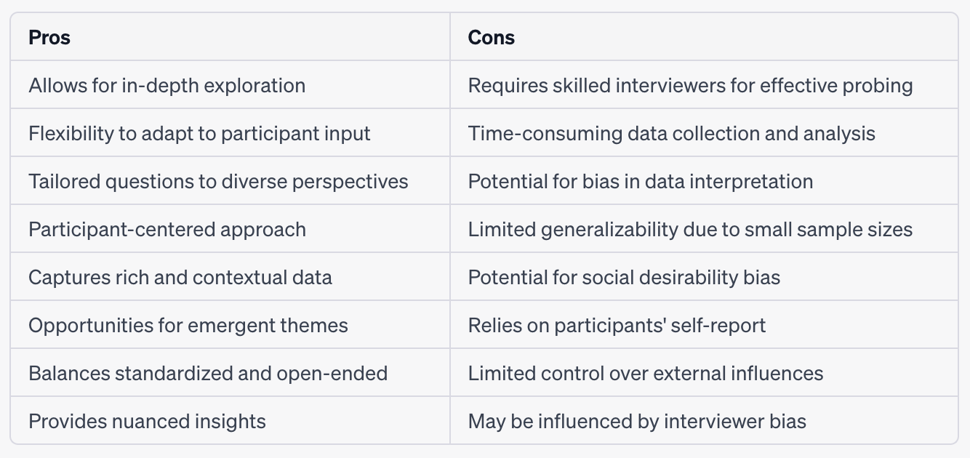

* + 1. Semi-structured interviews involve a flexible interview guide that provides a set of key **questions or topics to be explored.**
    2. The interviewer has the freedom *to probe, follow-up, and explore* participants' responses in more depth.
    3. This type of interview allows for *a balance between standardized questions and open-ended dialogue, enabling rich and detailed data collection.*
       1. Research Topic: Experiences of healthcare providers during the COVID-19 pandemic
       2. Example: In a semi-structured interview, healthcare providers are asked a set of key questions about their experiences and challenges during the COVID-19 pandemic. The interview guide covers topics such as workload, stress levels, coping strategies, and the impact on patient care.
       3. The interviewer has the flexibility to explore participants' responses in more depth, allowing for a comprehensive understanding of the diverse experiences and perspectives of healthcare providers.
  1. Narrative
     1. Narrative interviews focus on participants' life stories, personal experiences, or specific events.
     2. The interviewer encourages participants to share detailed narratives, providing a deeper understanding of their experiences, perceptions, and the meaning they attribute to those experiences.
     3. Narrative interviews emphasize storytelling and allow participants to construct a coherent narrative of their lives.
        1. Research Topic: Lived experiences of individuals with chronic pain
        2. Example: Narrative interviews are conducted with individuals living with chronic pain, allowing them to share their personal stories and experiences. The interviewer encourages participants to provide a detailed account of their pain journey, including the onset of symptoms, daily challenges, coping mechanisms, and interactions with healthcare providers.
        3. The focus is on capturing the narrative structure and meaning participants attribute to their experiences with chronic pain.
  2. unstructured interviews
     1. Unstructured interviews provide the greatest level of flexibility, allowing the interviewer to engage in a free-flowing conversation with participants.
     2. There is no predetermined set of questions, and the focus is on exploring participants' perspectives, experiences, and meanings in an open and natural manner.
     3. Unstructured interviews allow for deep exploration of topics *but require skilled interviewers to manage the conversation effectively.*
        1. Research Topic: Palliative care experiences of patients with terminal illnesses
        2. Example: In an unstructured interview, patients with terminal illnesses are invited to share their experiences and reflections on palliative care.
        3. The interviewer engages in a free-flowing conversation, allowing patients to express their thoughts, emotions, and personal narratives related to their experiences with palliative care. The focus is on capturing the richness of their stories and gaining a deep understanding of their needs, preferences, and challenges.

1. 9 steps described for developing a semi-structured interview guide
   1. 1. Define objective(s)
      1. Clearly articulate the research objectives and the specific research questions or topics you want to explore through the semi-structured interviews.
      2. This will guide the development of the interview guide and ensure alignment with your research goals.
      3. Research Objectives: Explore the challenges, benefits, and patient perspectives on telemedicine usage during the COVID-19 pandemic and identify factors influencing their satisfaction and acceptance of this healthcare delivery method.
   2. 2. Identify potential concepts/themes
      1. Conduct a thorough review of existing literature, relevant theories, and conceptual frameworks to identify key themes, concepts, and factors related to your research topic.
      2. This will help you develop a comprehensive understanding of the subject matter and inform the selection of interview questions.
      3. Key Themes (MeSH):
         1. Access to care
         2. communication with healthcare providers
         3. technological barriers
         4. privacy
         5. security concerns,
         6. patient satisfaction
         7. acceptance of telemedicine
   3. 3. Generate initial questions
      1. Based on the identified themes and concepts, generate a list of initial open-ended questions that can be used as a starting point for the interview guide.
      2. These questions should be broad and open-ended to encourage participants to share their perspectives and experiences.
      3. Can you describe your experiences with telemedicine appointments during the COVID-19 pandemic?
      4. What are the specific **challenges** you encountered when using telemedicine?
      5. How do you perceive the quality of communication with healthcare providers through telemedicine?
      6. Have you faced any difficulties related to the technology used for telemedicine appointments?
   4. 4. Organize questions into groups
      1. Group the initial questions into logical sections or topics to create a coherent structure for the interview guide. Arrange the questions in a logical flow that allows for a smooth progression of the conversation.
      2. Consider the sequencing of questions to ensure a comfortable and natural flow during the interview.
         1. **Section 1: Experiences with Telemedicine**
            1. Can you describe your experiences with telemedicine appointments during the COVID-19 pandemic?
            2. What were your expectations before your first telemedicine appointment?
         2. **Section 2: Challenges and Barriers**
            1. Have you encountered any challenges or difficulties when using telemedicine? If yes, please describe them.
            2. Did you face any technological barriers or issues during your telemedicine appointments?
         3. **Section 3: Communication and Patient Satisfaction**
            1. How would you describe the quality of communication with healthcare providers during your telemedicine appointments?
            2. Did you feel satisfied with the level of care provided through telemedicine?
   5. 5. Generate follow up/probing subquestions
      1. Integrate probing and follow-up questions to encourage participants to provide more detailed and nuanced responses. These probing questions should delve deeper into specific aspects or seek clarification on participants' initial responses.
      2. Probing questions can help explore emerging themes or unexpected insights during the interview.
      3. Can you provide specific examples to illustrate the challenges you faced during your telemedicine appointments?
      4. How did you navigate or overcome these challenges?
      5. What factors influenced your satisfaction or dissatisfaction with the quality of communication during telemedicine appointments?
   6. 6. Pilot
      1. Pilot test the interview guide with a small sample of participants who are similar to the target population. This will help identify any issues or areas that need improvement, such as unclear or redundant questions, and allow for refinements to be made to the interview guide before full data collection.
         1. 1. Conduct the semi-structured interviews with a small sample of patients who have experienced telemedicine appointments during the COVID-19 pandemic.
         2. 2. Pay attention to participants' responses, noting any unclear or redundant questions and seeking their feedback on the interview process.
   7. 7. Revise
      1. Based on the feedback and insights gained from the pilot testing, revise and refine the interview guide. Ensure that the questions are clear, concise, and capable of eliciting the desired information.
      2. Consider the phrasing of the questions to ensure they are unbiased and do not lead participants to specific responses.
         1. **Original Question:** Can you describe your experiences with telemedicine appointments during the COVID-19 pandemic?
         2. **Pilot Feedback:** Some participants found this question too broad and had difficulty organizing their thoughts.
         3. **Modified Question:** Can you share a specific telemedicine appointment experience during the COVID-19 pandemic that stands out to you, either positive or negative?
   8. 8. Input from experts
      1. Consult with experienced researchers or experts in the field to review and provide feedback on the interview guide.
      2. Their input can help enhance the clarity, relevance, and comprehensiveness of the questions, ensuring the interview guide is well-designed and aligned with best practices in qualitative research.
         1. Consult with healthcare researchers or experts in the field of telemedicine to review and provide feedback on the interview guide.
         2. Incorporate their suggestions and recommendations to enhance the relevance and comprehensiveness of the questions.
   9. 9. Finalize
      1. Incorporate the feedback and revisions into the interview guide, making it a final version ready for data collection.
      2. Document the interview guide with clear instructions for the interviewer on how to introduce the study, probe when necessary, and handle any ethical considerations.

**Lecture: Quantitative Methods - Survey Design**

1. Cross sectional versus longitudinal
   1. Longitudinal survey single or multiple groups over time (REPEATED MEASUREMENT)
      1. *Some surveys are designed to be repeated* ***within X time period, but not before….***
      2. In most clinical studies, the time period is based on:
         1. **recall period** of the phenomena (how long you remember X)
         2. **Expected rate of change** (e.g., 1 day versus 14 days?)
         3. **participant burden** (e.g., avoid survey fatigue)
         4. **event-based timing** (e.g., treatment schedules (cancer))
      3. Examples of Longitudinal studies
         1. **Chronic Disease Study:** In a longitudinal survey, researchers may follow a group of patients with a chronic disease (e.g., diabetes) over *several years to understand changes in their health outcomes,* treatment adherence, and quality of life.
         2. Data is collected at multiple time points to observe trends and developments.
         3. **Health Technology Adoption:** A longitudinal survey could be conducted to study the adoption and u*sage of a new health information technology system in a healthcare setting*.
         4. Data is collected over an extended period to assess the impact of the technology on workflow and patient outcomes.
         5. **Health Tracking Study:** In a longitudinal survey, researchers may track the health status and *behaviors of a cohort of pregnant women throughout their pregnancy and postpartum* period.
         6. Data is collected at different trimesters and postpartum to monitor changes and health outcomes
   2. Cross Sectional studies assessing exposures and outcomes at the same time/single time point
      1. Example of Cross sectional studies
         1. **Patient Satisfaction Survey:** A cross-sectional survey could be conducted in a hospital to assess patient satisfaction levels regarding the *quality of care, staff interactions, and overall hospital experience.*
         2. The survey is administered to a sample of patients who have recently received medical treatment at the hospital, and data is collected at a specific point in time.
         3. **Health Behavior Study:** A cross-sectional survey might be used to investigate the prevalence of certain health behaviors, such as *smoking, among a representative sample of adults in a community.*
         4. The survey collects data on smoking habits, demographics, and other relevant variables during a single data collection wave.
2. Ways in which ‘time’ might be determined for how often/frequently a survey should be administered (e.g. recall period as one example)
   * 1. In most clinical studies, the time period is based on:
        1. **recall period** of the phenomena (how long you remember X)
        2. **expected rate of change** (e.g., 1 day versus 14 days?)
        3. **participant burden** (e.g., avoid survey fatigue)
        4. **event-based timing** (e.g., treatment schedules (cancer))
3. The name of the SDoH toolkit developed by the NIMDH
   1. SDoH, mental health, substance use disorders, etc... -> <https://www.phenxtoolkit.org/>
      1. The PhenX (consensus measures for Phenotypes and eXposures) Toolkit is a web-based catalog of recommended measurement protocols of phenotypes and exposures suitable for inclusion in genomic, clinical, and translational research studies with human participants
4. The name of the research organization that managers the ‘Health Tech Assessments’ from the US government
   1. AHRQ - Agency for Healthcare research and Quality
   2. AHRQ - Health Tech Assessments -> <https://digital.ahrq.gov/health-it-tools-and-resources/evaluation-resources/health-it-survey-compendium-search>
5. What is a PRO
   1. Patient Reported Outcome (PRO)
      1. PRO Assessment Tools
         1. PROMIS - ([link](https://www.ncbi.nlm.nih.gov/pmc/articles/PMC2810630/))
         2. AHRQ - ([link](http://www.ahrq.gov/professionals/prevention-chronic-care/improve/system/health-assessments/health-assessment-ap4.html))
         3. CA-SHA - ([link](http://www.dhcs.ca.gov/formsandpubs/forms/Pages/StayingHealthyAssessmentQuestionnaires.aspx))
         4. **SF-36/12 -** ([link](https://www.ncbi.nlm.nih.gov/pubmed/1593914))
   2. Survey Design
      1. Hypothesize Conceptual Framework
      2. Get Feedback, Adjust → Adjust Conceptual Framework and Draft Instrument
      3. Confirm Scoring, Approach →Confirm Conceptual Framework and Assess Other Measurement Properties
      4. Psychometrics →Collect, Analyze, and Interpret Data
      5. Validity Studies/ Modify and continuous enhancements →Modify Instrument
6. What is the PROMIS
   1. Patient Reported Outcome Measurements (PROMs)
   2. **P**atient-**R**eported **O**utcomes **M**easurement **I**nformation **S**ystem
   3. PROMIS® (Patient-Reported Outcomes Measurement Information System) is a set of person-centered measures that evaluates and monitors physical, mental, and social health in adults and children. It can be used with the general population and with individuals living with chronic conditions. (NOTE : IT WAS IN SLIDES AS SCREEN SHOT)
7. **Pros Why use**
   1. **Efficiency and Scalability:** Surveys allow researchers to collect data from a large number of respondents efficiently, making them a scalable method for data gathering.
   2. **Quantitative and Qualitative Data:** Surveys can capture both quantitative data (e.g., numerical ratings) and qualitative data (e.g., open-ended responses), providing a comprehensive view of the research topic.
   3. **Standardization:** By using structured questionnaires, surveys ensure consistency in data collection, reducing potential bias and facilitating easier data analysis.
   4. **Generalizability:** When conducted properly, surveys can produce findings that are representative of the target population, enabling researchers to make broader inferences.
   5. **Anonymity and Confidentiality:** Respondents' anonymity in surveys can encourage honest and candid responses, leading to more accurate data. Researchers can also ensure confidentiality to protect sensitive information.
   6. **Cost-Effectiveness….Ease of Administration**… **Longitudinal Studies**
8. **Potential issues to remember**
   * 1. **Response Bias: Respondents may provide socially desirable answers or be influenced by the wording of questions, leading to response bias and potentially inaccurate data.**
     2. **Limited Depth: Surveys might not capture the depth of understanding that qualitative methods like interviews or focus groups can provide.**
     3. **Non-Response Bias: Some individuals may choose not to participate in surveys, introducing the possibility of non-response bias and affecting the representativeness of the sample.**
     4. **Question Wording Issues: Poorly worded or ambiguous questions can lead to misinterpretations and unreliable data.**
     5. **Overgeneralization: While surveys can provide valuable insights, it's essential to be cautious when making broad generalizations based on self-reported data.**
     6. **Lack of Context: Surveys may lack the context that researchers can gather through qualitative methods, potentially limiting the understanding of complex issues.**
     7. **Potential for Survey Fatigue….Sampling Challenges:**
     8. **Cost-Effectiveness….Ease of Administration… Longitudinal Studies**
9. 7 steps to selecting a survey instrument
   1. **Purpose**
      1. Define the specific goals and objectives of the survey or study. *Identify what you want to measure* and the *type of information* you need to collect.
         1. **Example:** To assess *patient satisfaction* with healthcare services in a hospital setting and identify areas for improvement in the quality of care.
   2. **Constructs**
      1. Determine the psychological constructs, traits, or attitudes you want to measure. Ensure that the survey items align with these constructs.
         1. **Example:** Measuring self-esteem, stress levels, and coping mechanisms among university students.
   3. **Validation and Reliability**
      1. Check if the survey has undergone validation studies to establish its validity and reliability.
      2. Look for evidence supporting the accuracy and consistency of the instrument (e.g., PUBMED)
         1. **Example:** Selecting a well-validated and reliable anxiety scale, such as the Beck Anxiety Inventory (BAI), for a clinical study on anxiety disorders.
   4. **Target population**
      1. Identify the specific group or population for whom the survey is intended.
      2. Ensure that the survey is appropriate for the target audience in terms of language, cultural relevance, and content.
         1. **Example:** Choosing a language-appropriate survey for assessing parenting practices among immigrant families from diverse cultural backgrounds.
   5. **Survey type**
      1. Cross-sectional or longitudinal
      2. Choose a survey with your research objectives and timeline.
      3. Keep in mind that some surveys may be developed to only be given once every 2 weeks, while others may be delivered daily
         1. **Example**: Considering participant time constraints, selecting a short and focused satisfaction survey for post-event feedback in a conference setting
   6. **6. Response Options**
      1. Evaluate the response options (e.g., Likert scales, yes/no, multiple-choice) to ensure they are suitable for the constructs being measured and allow for meaningful data analysis.
         1. **Example**: Using a survey that utilizes Likert scale with clear response options (e.g., strongly agree to strongly disagree) to assess attitudes towards vaccination in a public health survey that can be used to perform basic descriptive and inferential statistics
   7. **Copyright Restrictions or Permissions**
      1. Check whether the survey instrument is subject to copyright protection or requires specific permissions for use.
      2. Ensure compliance with any copyright restrictions or licensing agreements when using the survey in your research or assessments.
      3. If needed, seek permission from the original authors or copyright holders before using the survey.
         1. **Example:** Verifying that a proprietary career assessment survey has permission for use in research and obtaining the necessary licensing if required.
10. Examples of when to not use surveys
    1. **Sensitive/personal topics** (EOL, child abuse, domestic violence, etc..)
    2. **Limited resources / tech** (Elderly population? Low tech readiness ir low-income community? Data security issues, internet availability?)
    3. **Lack of clarity of research/objective** (undefined target population, exploratory research, have multiple research questions yet to refine, changing focus area…)
    4. **Temporal constraints** (real time events, emergency situations/crisis response, tight deadlines, seasonal variability, etc…)
11. **Example when to use surveys**
    1. Require large sample size (cost effective)
    2. Quantitative/structured data
    3. Conducting needs assessment (software, health, organization, etc..)
    4. Quality improvement initiatives
    5. Baseline/longitudinal studies
12. Potential reasons why you may need to create a survey
    1. **Evaluating Program Outcomes:** Non-profit organizations or government agencies running specialized programs (*e.g., mental health interventions, educational programs*) might need to evaluate the program's impact.
       1. Pre-existing generic surveys might not align perfectly with the program's objectives.
       2. Creating a survey tailored to the program's outcomes enables more accurate assessment of its effectiveness.
    2. **Employee Satisfaction Surveys:** In a workplace, standard employee satisfaction surveys might not delve into specific issues or concerns that are unique to that organization.
       1. Creating a customized survey allows employers to collect feedback on areas such as company culture, leadership, or specific employee benefits, which may not be adequately covered by off-the-shelf surveys.
    3. **Local or Cultural Relevance:** In international or culturally diverse settings, generic surveys might not be culturally sensitive or relevant to local practices and beliefs.
       1. Developing culturally adapted surveys ensures that the questions and response options resonate with the target population and improve data accuracy.
    4. **User Experience (UX) Research:** In UX research, generic usability surveys might not fully capture users' specific interactions with a product or service.
       1. Designing a survey tailored to the unique user journey and features of the product allows for more precise feedback on the user experience.
    5. BUT THEY ARE HARD TO GET RIGHT
       1. Poor survey designs will produce the following:
       2. **1. Bad Data:** poorly constructed surveys may lead to inaccurate or misleading results
       3. **2. Lack Validity**: validity -> extent to which survey accurately measures what it intends to measure (construct, content, criterion)
       4. **3. Lack Reliabilit**y / Consistency: give you different results over time and across different administrators
       5. **4. Ambigious/Biased results:** introduce bias via leading questions, double-barreled questions, complex language
       6. **5. Inadequate representation**: not adequately capture the perspectives and experiences of the target population;
13. The 5 steps outlined by the FDA for creating a survey instrument

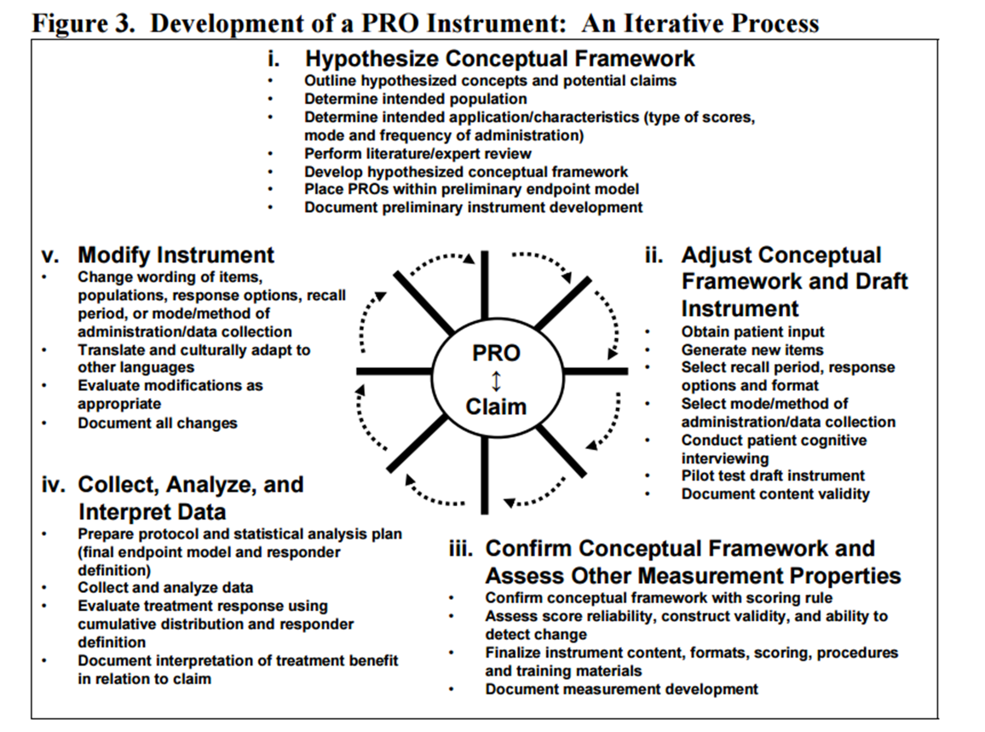

* 1. Hypothesize Conceptual Framework
  2. Adjust Conceptual Framework and Draft Instrument
  3. Confirm Conceptual Framework and Assess Other Measurement Properties
  4. Collect, Analyze, and Interpret Data
  5. Modify Instrument
  6. **Require large sample size (cost effective)**
  7. **Quantitative/structured data**
  8. **Conducting needs assessment (software, health, organization, etc..)**
  9. **Quality improvement initiatives**
  10. **Baseline/longitudinal studies**
      1. **Efficiency and Scalability: Surveys allow researchers to collect data from a large number of respondents efficiently, making them a scalable method for data gathering.**
      2. **Quantitative and Qualitative Data: Surveys can capture both quantitative data (e.g., numerical ratings) and qualitative data (e.g., open-ended responses), providing a comprehensive view of the research topic.**
      3. **Standardization: By using structured questionnaires, surveys ensure consistency in data collection, reducing potential bias and facilitating easier data analysis.**
      4. **Generalizability: When conducted properly, surveys can produce findings that are representative of the target population, enabling researchers to make broader inferences.**
      5. **Anonymity and Confidentiality: Respondents' anonymity in surveys can encourage honest and candid responses, leading to more accurate data. Researchers can also ensure confidentiality to protect sensitive information.**

1. Key Concepts
   1. **Validity**: assesses the appropriateness and meaningfulness of the inferences and interpretations made based on the test scores [*content, construct, criterion, etc….*]
   2. **Reliability**: consistency, stability, and reproducibility of measurements
   3. **Accuracy** (Precision): how close a measurement or assessment is to the true or accepted value
   4. **Item Response Theory (IRT):** a statistical method used to analyze how individuals respond to individual test questions
   5. **Factor (cluster) Analysis:** helps us find hidden patterns and relationships among different variables in a dataset, allowing us to group related variables together into common factors.
2. Construct versus Criterion validity
   1. Content Validity
      1. The degree to which the items in a test represent *the entire domain or content of the construct being measured*.
      2. It focuses on whether the test adequately covers **all aspects of the construct** it aims to measure
      3. It involves expert judgment and content review to ensure that the items are relevant, comprehensive, and representative of the construct.
      4. Content validity is typically established through a thorough item development process, expert reviews, and pilot testing.
   2. Construct Validity
      1. Evaluates the degree to which the test measures the ***theoretical construct*** it claims to measure, *examining relationships with other variables and its theoretical implications.*
      2. It involves multiple types of evidence, such as convergent validity (positive relationships with related constructs), divergent validity (negative or unrelated relationships with unrelated constructs), and known-groups validity (ability to differentiate between groups known to differ in the construct).
   3. Criterion Validity
      1. Criterion-related validity evaluates h*ow well the test scores correlate with an external criterion or gold standard measure* of the construct. It is divided into two subtypes:
      2. **Concurrent** Validity: This assesses the relationship between the test scores and the criterion measured at the same time. For example, comparing scores on a new intelligence test with scores from an established intelligence test for the same group of individuals (++ strong correlation)
      3. **Predictive** Validity: This assesses the ability of the test scores to predict future performance on a relevant criterion. For example, using scores on an admission test to predict students' academic success in college (87% accuracy)
3. What is the PSI - why it was developed, what gap is filling
   1. **Parsley Symptom Index** (PSI)
   2. A theoretically driven, and empirically validated patient reported outcome (symptom) tool
   3. For understanding **health** in adults (18-50) that are not severely ill, have a major disability
   4. Provides a total score for **physical health**, in addition to subscores for individual body systems
   5. Captures symptom-related changes for a 14 day period
      1. **Domain Categories** -> Will be based on physiological systems (e.g., cardiac, GI, etc..) for easier communication of results/health status for patients
      2. **Item Response** -> Continuous (0-100) sliding scale to allow for *improved capture of symptom variance and increased specificity of symptom variance across time*
      3. **Symptom Selection Validation** -> Symptoms will be selected through *multiple iterations of health care provider feedback, retrospective analysis of patients (e.g., most common symptom complaints), and based on CDC National Health Interview Survey (NHIS - 2015) most frequently cited symptoms/conditions* for adults 18-45
      4. **Outcomes** - Health care providers receive a breakdown/score of each system in addition to a global/cumulative health functioning score

**Lecture(s) Python:**

1. Python - what is it / examples of what can it be used for
   1. programming Language
   2. What can it do?
      1. Web development
      2. Mobile development
      3. API creation
      4. Data science
      5. Database creation
2. What the most current version of Python is / what the two big versions are (python 2 versus python 3)
   1. Python Version History
      1. 2.5.x / 2.6.x / 2.7.x / 2.8.X / 3.X / 3.X (beta)
   2. “Mainstream” version in 2025 is 3.13.x •
   3. The new kid on the block is 3.14
      1. Python Shell
         1. Via terminal / Google Shell / [repl.it](http://repl.it)
      2. IDE
         1. Via Visual Studio Code / Google Shell / Spyder
      3. Notebook
         1. Via Local python / Google Colab / AWS pagemaker
3. How we can run python code (terminal, python shell, IDE)
   1. Local installation
   2. Web browser and cloud
   3. Python Shell :
      1. Navigate to your project's directory and run the following command:

source virtualenv1/bin/activate

* + 1. Then you can begin to install the libraries you want, e.g.:

pip install pandas

* + 1. And once done, you can then de-activate:

Deactivate

1. What an IDE is
   1. IDEs are software applications that provide a comprehensive and unified environment for software development.
   2. They typically include a code editor, debugger, build automation tools, and other features to simplify the development process.
   3. IDEs are designed to enhance productivity and provide a seamless development experience by integrating various tools and functionalities.
   4. Open, modify, and create files using the code editor
2. What is google shell
   1. Google Shell
   2. <https://shell.cloud.google.com>

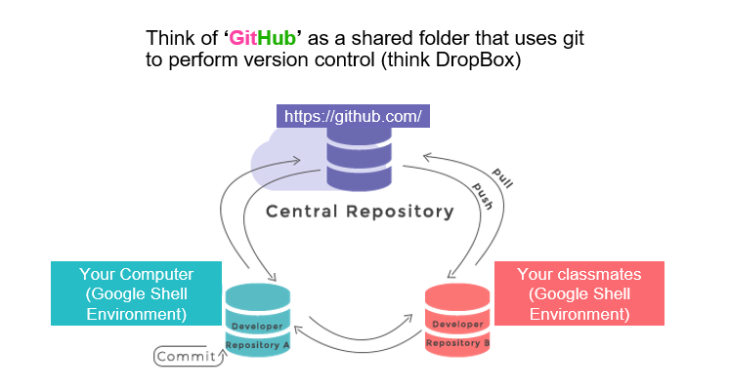

1. Main variable types in python (int, float, strings, lists, dictionaries, ranges, tuples)
   1. Numeric (int, float)
   2. Text (string)
   3. Boolean (T/F)
   4. Sequence types (list, tuple, range)
   5. Mapping type (dictionary)
   6. None Type (none)
   7. File Type (file)
2. Difference between a python dictionary and JSON
   1. Keys Representation:
      1. Python dictionaries allow keys to be non-string and can use either single or double quotes for keys.
      2. JSON keys must always be enclosed in double quotes.
   2. Data Types:
      1. Python dictionaries allow any data type for values, including functions and complex objects.
      2. JSON has a limited set of data types, and all values must be one of the specified types (string, number, boolean, null, array, or another JSON object).
   3. Comments:
      1. Python dictionaries can include comments (lines starting with #), which are ignored by the Python interpreter.
      2. JSON does not support comments, and any comment-like content will result in a syntax error
3. What is a module
   1. A module in Python is a file containing Python code. It can contain functions, classes, variables, and other Python objects.
   2. Modules are used to break down the code into smaller, more manageable pieces, making it easier to maintain and understand.
   3. To create a module, you simply create a .py file with Python code, and you can then import and use its contents in other Python scripts.
   4. **The most common way to import a module is using the** import **statement. It loads the entire module into memory, and you need to use the module name to access its functions, classes, or variables.**
4. How do you load modules into python code
   1. **You can provide an alias (short name) to the module when importing. This is useful for modules with long names or to avoid name conflicts.**
   2. The process of locating and loading modules is known as *module resolution.*
   3. Python follows a specific order to search for modules based on a set of predefined paths, which include directories, zip archives, and other locations
   4. Example: import pandas pd
5. What are pypi and pip, and how do they work together - what type of modules do they help you interact with?
   1. **pip (Python Package Index):** pip is the default package management system for Python.
   2. It allows you to easily install, manage, and uninstall third-party Python packages and libraries.
   3. pip provides access to the *Python Package Index (PyPI)*, a repository of thousands of open-source packages created and maintained by the Python community.
   4. Pypi (**Py**thon **P**ackage **I**ndex) is a central repository that hosts a vast collection of open-source Python packages and libraries.
   5. PyPI serves as a hub for developers to share their code with the Python community
   6. Makes it easy for other to discover, download, and use these packages.
   7. You can use pip to install packages by running the following command in your **terminal**: you do not perform this command within python, but outside of python - think of ***pip*** as another piece of software that is separate from python - it ‘helps’ it: pip install package-name
6. Requirements.txt file:
   1. What is a requirements.txt file?
      1. Pip allows you to specify a list of packages and their versions in a special text filed called a ‘requirements.txt’ - this can then be used to very quickly install the packages you need on a new machine or new environment
      2. pip freeze > requirements.txt
   2. What is contained within it?
      1. Pip allows you to specify a list of packages and their versions in a special text filed called a ‘requirements.txt’ - this can then be used to very quickly install the packages you need on a new machine or new environment
         1. numpy==1.23.0
         2. pandas==1.3.2
         3. matplotlib==3.4.3
         4. tensorflow==2.6.0
         5. scikit-learn==0.24.2
         6. Django==3.2.7
         7. Flask==2.0.1
         8. requests==2.26.0
         9. beautifulsoup4==4.10.0
         10. SQLAlchemy==1.4.23
   3. Why would you want to create one?
      1. Pip allows you to specify a list of packages and their versions in a special text filed called a ‘requirements.txt’ - this can then be used to very quickly install the packages you need on a new machine or new environment
      2. pip freeze > requirements.txt
   4. How would you load a requirements.txt file?
      1. pip install -r requirements.txt
      2. nano touch requirements.txt - to read the requirements.txt

**Lecture(s) Github:**

1. What is git? What does it do?
   1. Sharing and version control for your code
   2. Git is a distributed version control system (software) that allows developers to track changes in their code over time. [code=.txt, .md, .py, .sql,. .doc, ect]
2. How does github relate to git?
   1. Github -> (Git) —> is the software; (hub) —> is that it is a place where the git stuff is stored

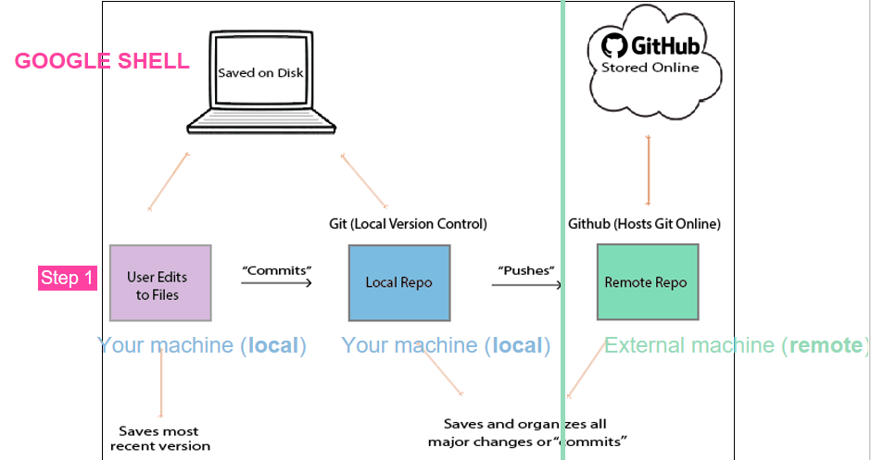

1. What problems does git solve?
   1. **Collaboration and Teamwork**: Data science projects often involve collaboration with team members, data engineers, analysts, and stakeholders. GitHub provides a centralized platform for collaboration, enabling team members to work on different parts of the project simultaneously, merge their changes, and review each other's work through pull requests.
   2. **Reproducibility**: Data science is heavily focused on reproducibility. By using Git, data scientists can keep track of all the code, data, and environment configurations used in their analyses. This ensures that other team members or researchers can reproduce the results easily and accurately.
   3. **Code Review**: GitHub's pull request feature allows for code review before merging changes into the main project. Code review helps identify potential errors, suggests improvements, and ensures that the codebase adheres to best practices and standards.
   4. **Project Documentation:** GitHub provides tools for project documentation, including README files, wikis, and GitHub Pages. Data scientists can use these features to document their projects, explain methodologies, and share insights with team members and the broader community
2. Be able to define and explain the following:
   1. Repo - **Repository** (Repo):A repository is a collection of files and folders (codebase)  
      It also contains the entire history of changes made to those files. It's where your project and its version history are stored (contained inside of a hidden .git folder)
   2. Commit - **Commit**: A commit is a snapshot of changes made to the code at a specific time. It represents a new version of the codebase with a unique identifier (SHA-1 hash).
   3. Branch - **Branch**: A branch is a separate line of development that allows you to work on features or bug fixes without affecting the main codebase. You can merge branches back into the main branch when the work is complete.

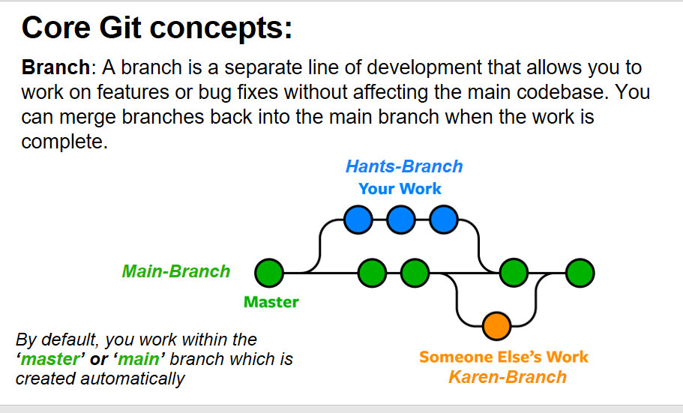

* 1. Pull Request (PR) - **Pull Request** (PR):  
     A pull request is a request to merge changes from one branch (usually a feature branch) into another (typically the main branch).  
     It allows others to review the changes before merging.
  2. Cloning -**Cloning**, in the context of version control systems like Git, refers to the process of creating a copy of a remote repository on your local machine.  
     When you clone a repository, you are not just copying the latest snapshot of the files; you are also creating a complete copy of the repository's history (branches and metadata).  
     This allows you to have the entire version history of the project locally, enabling you to work on the code, view previous commits, create branches, and more, even when you are offline.
     1. 1. Access Google Cloud Shell: Open Google Cloud Console (shell.cloud.google.com) to get your environment open
     2. 2. Clone the Repository: In the Google Cloud Shell terminal, navigate to the directory where you want to clone the repository. Use the git clone command with the URL of your GitHub repository
  3. Push
     1. To push the committed changes from your local machine to the GitHub repository, use the following command: - **git push**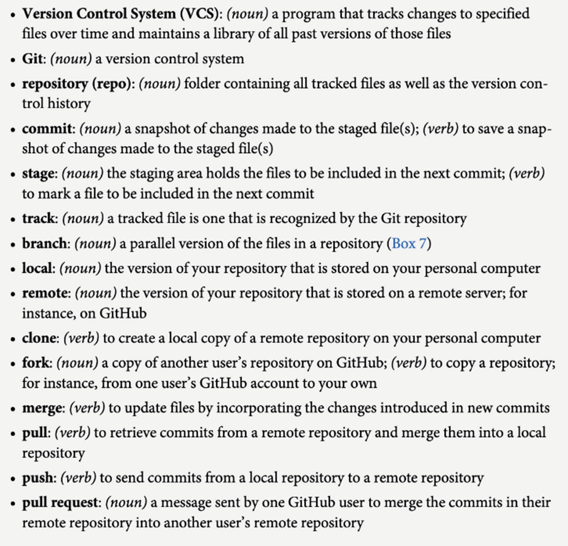

1. Gitignore files
   1. What is it and its purpose
      1. You can modify, and tell what you want to avoid that is specific to your project
   2. Where are they found in your code/repo
      1. gitignore
      2. Same level as readme.md
2. Env files
   1. What is it and its purpose
      1. A virtual environment is an isolated environment that contains its own Python interpreter and libraries.
      2. It allows you to create a sandboxed environment where you can install and manage packages separately from the system-wide Python installation.
      3. Virtual environments are incredibly useful for managing dependencies, avoiding version conflicts, and keeping your projects organized.
   2. What is their structure (hint: it's like a dictionary)
      1. List of Lists?
      2. These contain list of references/other projects that relate to specific topics of interest
   3. What python pip package is used to load in env into python script
   4. pip install pandas
   5. python -m venv virtualenv1